Homework 12

Problem 1. Pressure drop per unit length in a pipe is a function of the pipe diameter, density, viscosity, and average velocity. Use the PI method to find the dimensionless groups. Your method can result in any consistent set of PI's, but you should write these in terms of meaningful (friendly) groups (think about relevant force ratios here). Table 7-5 may help.

Problem 2.
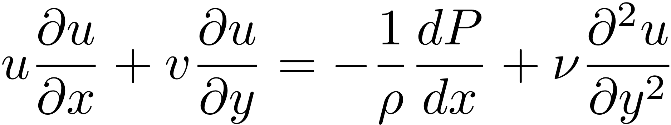On the last homework, you found the growth of the boundary layer. The boundary layer equation at high Reynolds number is given by:

- Nondimensionalize this equation using parameters U, L, δ, ρU², and Uδ/L to normalize u, x, y, P, and v, respectively. Here, U is the free stream u velocity, L is the plate length in the x direction, δ is the boundary layer thickness in the y direction.
- Given the scaling arguments in our lecture (that is, each term is the product of a quantity that gives the size of the term, and a nondimensional term of order unity), show how the boundary layer grows with L. Stated another way, when nondimensionalized, and normalized, each whole additive term is O(1). Using this, find the functional FORM of δ. That is, write δ as a function of the other paramters.

