Lab 11: Tank Blowdown
SAFETY SECTION: This lab deals with compressed air. Compressed gases, when compared to incompressible liquids, have additional safety concerns because a lot of energy can be stored in a compressed gas. If that energy is released suddenly, it can propel dust and other solids at high speed and create harmfully large sound levels. Do not place your face or head in the path of high-speed gas flow. Use ear plugs to protect your hearing while discharging pressurized air. Long pants, closed toed shoes and safety glasses must be worn at all times.
You will fill a tank with compressed air at pressure around 65-70 psig, the max we can get in the lab. The tank is rated to handle a pressure of 200 psig. In addition, there is a pressure relief valve on the tank to release pressure at 125 psig. Therefore, the risk of a tank rupture is negligible.
Begin your lab by holding a team planning session (3 minutes):
- This lab will require additional preparation time. You should have previously read the last 2 ½ pages of “Tank Blowdown Math” document posted on Learning Suite, seeking to understand the principles of compressible flow and the key equations you will need to analyze your data.
- Review the safety information above.
- One person should serve as leader/coordinator. All team members should strive to make the team function better through various roles: observer, recorder, devil’s advocate, etc. Ask for each other’s input and opinions, help each other, and try to come to consensus after an appropriate amount of brainstorming and analysis.
- Make a plan for how you will complete the lab activities. Each person should turn in their own lab report and Excel sheet produced independently from teammates. At the end of the hour, after properly shutting down the equipment, get the TA to initial the end of your report.
Background: It is helpful to be able to estimate how long it will take to empty a tank filled with gas through an orifice or valve. If a discharge coefficient and geometry for an orifice is known, one can compute the flow rate leaving the tank, given temperature and pressure in the tank. However, in the case of a complete blowdown, conditions in the tank, and therefore in the orifice, are changing in time. To correctly predict what will happen requires use of a transient mass balance and a solution to the resulting differential equation. The document “Tank Blowdown Math” provides needed equations and background, particularly the last 2 ½ pages.
Project: In this lab you will do a transient measurement on a tank while it discharges and then compare results to theory. For the theory you will use the coefficient of discharge $C_{d}$, orifice diameter, and tank volume you previously determined in the Compressible Flow lab. Make sure you are using the exact same orifice and tank apparatus, as they may have slight differences! Once done with experiment and theory you will produce a summary graph.
- Pre-Lab Preparation: Answer the following questions to prepare for the data collection and analysis

  - What is the tank volume you determined in the Compressible Flow lab?

  - What are the similarly determined values of $C_{d}$ and $d_{*}$ for the orifice you intend to use?

  - Compute the discharge time constant $τ$ for your apparatus. Show your calculations. This allows you to predict approximately how long the discharge will take.

- Perform the tank blowdown experiment.
  - First fill the tank to its maximum pressure, close the filling valve, and allow pressure to equilibrate. Make a plan for the time increments at which you will record tank pressures during blowdown. Generally, you need more frequent measurements at the beginning (when pressure is changing rapidly) and less frequent measurements at the end.

  - Record time vs. tank pressure while emptying the tank though the designated orifice. Continue making measurements until gauge pressure drops below the level required for choking flow.

  - Leave the tank depressurized, but with valves closed, when you are done with the experiment.

  - Produce a plot of your data (discrete points), compared to smooth theoretical blowdown curves for the isothermal and adiabatic cases. Your plot should be formatted exactly like the following example plot. Notice that gauge pressure is plotted, meaning that absolute pressures in the theory must be converted to gauge pressures. Attach a printout of your Excel sheet containing your raw experimental data and your plot to this report.

Example Plot:

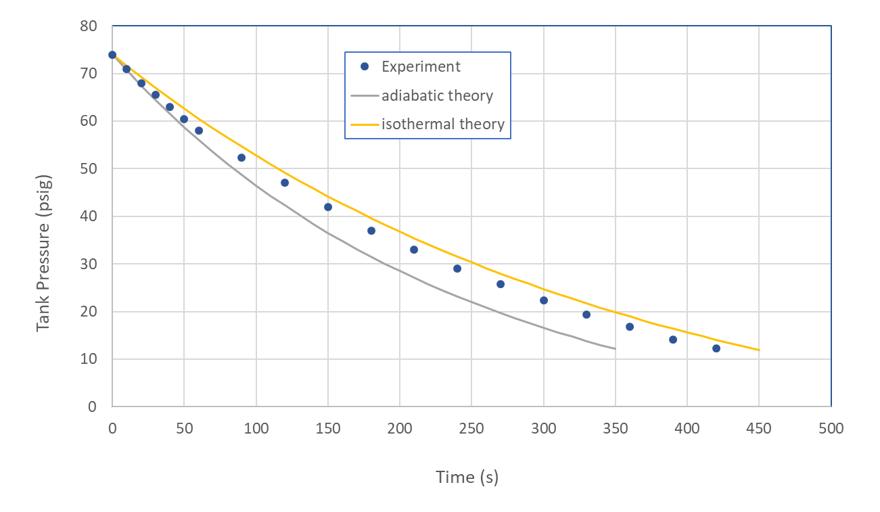

  - Based on your results, is your previously determined discharge coefficient accurate? If not, what value would work better? Do your results suggest that the experiment is closer to the isothermal or adiabatic tank conditions assumed in the theory? Explain.

_________________________________________________________________________________
Grading Rubric (to be completed by TAs)
 | Points | Max
Completed Activities and write-up |  | 5
Calculations Accurate |  | 5
Attached Excel and properly formatted graph |  | 4
Safety and equipment shutdown TA initial:______ |  | 1
Total |  | 15

