Lab 5: Pump Cart Orientation
Group Number: _______ Section Number:________
Name ___________________________________
Other team members ___________________________________________________________________
Circle the name of the person who acted as leader/coordinator
SAFETY SECTION:
The Pump Cart is an experiment in progress. It contains equipment that include electrical circuits, a pump, and valves. Part of this lab is to determine safety issues that you will need to keep in mind as you do Labs 6-9. Please alert the instructor or TA if you have a safety incident. As always, long pants, closed toed shoes and safety glasses must be worn at all times.
Begin your lab by holding a team planning session (3 minutes):
- Review the lab and read the safety section if you haven’t already.
- One person should serve as leader/coordinator. All team members should strive to make the team function better through various roles: observer, recorder, devil’s advocate, etc. Ask for each other’s input and opinions, help each other, and try to come to consensus after an appropriate amount of brainstorming and analysis.
- Make a plan for how you will complete the lab activities. Each person should fill out their own lab report as activities are completed. Unlike other reports, the TA does not need to initial the end of your report. Some additional time may be needed after the lab time to complete the work.

Background: Pumps, pipes, and fittings are fundamental to chemical engineering processes. The Pump Cart will help you better understand these devices and how performance calculations can be done. To get the most out of the upcoming labs, you need to understand exactly what is present on the Pump Cart. As a chemical engineer you must be able to predict and measure pressure gain due to a pump and pressure drops across straight sections of pipe and across fittings (valves, elbows, bends, etc.) that connect to those sections.
Project: In the activities below, you will carefully examine the Pump Cart (without turning anything on) and diagram what is present on the cart. You will also do a safety audit to anticipate possible safety concerns with the equipment. The diagram you create is to assist you in Labs 6-9, so attempt to make it in a form that will be useful to you. If you have extra time after completing these activities, you can begin working on Lab 6.
- Pump Cart Equipment: Familiarize yourself with the equipment by identifying the following items (put a number to the right of each letter, indicating how many items you found):
  - ____ Liquid storage tank
  - ____ Centrifugal pump
  - ____ Primary control valve (powered by electricity and compressed air)
  - ____ Pressure regulator that reduces the house air pressure to that required by the control valve
  - ____ Primary flow meter (bigger and with a digital readout screen)
  - ____ Secondary flow meter (smaller and without digital readout screen)
  - ____ Digital pressure-difference gauges, each having two input pressure lines
  - ____ Electronic control boxes for controlling pump speed and control valve position, and recording pressure readings
  - ____ Manual ball valve (not meant to precisely control flow, only to turn it on or off quickly with a handle)
  - ____ Manual globe valve (meant to precisely control flow by rotating a knob)
  - ____ 90-degree elbow bend in the pipe or “L”
  - ____ 180-degree bend in the pipe or “U”
  - ____ “T” connection in the pipe (ignore the top spigot, and the T-connections on the pressure taps don’t count since they are not part of the flow circuit).
  - ____ Straight Reducer that connects different-diameter pipes

- Process Flow Diagram: Attach a hand-drawn diagram of the primary liquid flow path beginning with the tank and ending with the tank, identifying key equipment and fittings along the way. Your diagram should also indicate which pressure taps in the flow path connect to which pressure gauges. Also note the sections that have ¾-inch (nominal) or smaller pipes. This diagram will assist you later when you need to determine pressure drops across particular sections, so you may want to make an extra copy of it before turning it in.

- Pump Cart Control Interface
  - The pump cart is controlled via a control interface that runs in the Blue Moon browser on a laptop. Familiarize yourself with this interface. Identify the following:
    - Main power switch
    - Pump on/off switch
    - Manual Control Override
  - Note the parts that are user inputs versus gauges/reported values.
  - You can turn the pump on and off with the pump switch, and change the pump speed with the Pump Speed setpoint. The actual pump speed (RPM) and pump motor power (W) are reported. Identify these.
  - There are two modes of operation: manual and automatic. We’ll run manual.
    - Identify the manual switch again.
    - Note the horizontal slider below the switch that lets you set the valve position. You can also set the value directly using the box to the right.
    - The valve position will determine the flow through the system. Note where the liquid flowrate is reported.
    - There is also a flowmeter that reports the flowrate through the bypass section. Note this indicator.
    - When in automatic control, there are several input boxes. We won’t be using these, but you should identify them so you know to ignore them: flowrate setpoint, Kc, Ti, Td.

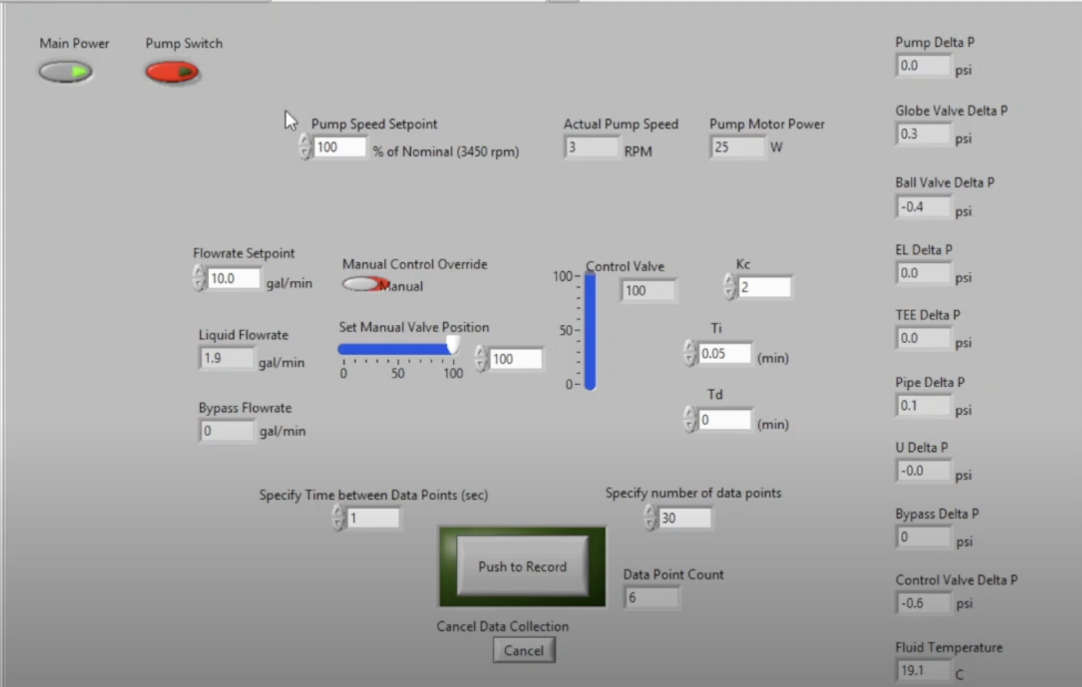
  - There are pressure taps in the system that record the pressure. Identify these on the control screen.
  - You can save system measurements to a data file. There are two boxes to specify the time increment between data points, and the number of data points to record.
  - Identify these two inputs.
  - What will influence the values you choose?
  - Identify the button to start recording the results.
  - When finished scroll to the bottom of the screen to see the file. You can save this to your J: drive.
  - A typical workflow will be: turn on the main power; turn on the pump; set desired pump speed; turn on manual control; set some fixed valve position; wait for the system to equilibrate (roughly constant flow reported); record data by specifying time between points, number of points, click the record button, wait for completion; view/save data file.
  - If available, run through this workflow on the real system.

- Safety: Do a safety audit and identify all the potential hazards with this equipment. Consider electrical, mechanical (pinching of fingers, impact with body parts), thermal, chemical exposure hazards. Summarize your findings and how you can mitigate or avoid these hazards while operating the equipment.

_________________________________________________________________________________
Grading Rubric (to be completed by TAs)
 | Points | Max
Completed activities and safety write-up |  | 5
Accurately identified numbers of equipment |  | 2
PFD shows sufficient detail and care |  | 3
Total |  | 10

