Lab 3: Vapor Pressure
Group Number: _______ Section Number:________
Name ___________________________________
Other team members ___________________________________________________________________
(Circle the name of the person who acted as leader/coordinator)
Safety
While handling the syringes or flask there is the possibility of an accidental spill. You should at all times wear long pants, closed toed shoes, and safety glasses. Gloves are recommended. If a syringe is not closed properly the fluid could be expelled. If liquids are spilled they must be cleaned up promptly. Please alert the instructor or TA if you have a safety incident.
For the last part of the lab you will be dealing with a hot plate and flask; be sure to handle with care and use appropriate caution.
Begin your lab by holding a team planning session (5 minutes)
- Review the lab and read the safety and background sections if you haven’t already.
- One person should serve as leader/coordinator. All team members should strive to take make the team function better through various roles: observer, recorder, devil’s advocate, etc. Ask for each other’s input and opinions, help each other, and try to come to consensus after an appropriate amount of brainstorming and analysis.
- Make a plan for how you will complete the lab activities. Each person should fill out their own lab report as activities are completed. At the end of the hour, after cleaning up, get the TA to initial the end of your report.
Background
As a chemical engineer you need strong intuition about how pressure is created in systems that are a pure component vs. a mixture. Vapor pressure or saturation pressure is a temperature-dependent property of a molecule that can be measured and tabulated and therefore frequently can be looked up online. One potentially confusing thing is that the tabulated vapor pressure of a molecule may not be the actual pressure of the vapor or gas phase for a particular situation, in other words, vapor pressure is not necessarily the pressure of the vapor! This lab is to help you understand the following two key cases.
- Pure-component system:
  - If a system contains a pure liquid (species A) and nothing else, then the pressure of the system must be above the vapor pressure of molecule A.
  - If the system contains two phases (liquid A and vapor A) then the system pressure is exactly at the vapor pressure of A. The amount of A in the gas phase will adjust (gas will convert to liquid and vice-versa) in order to maintain that pressure.
  - If the system contains only vapor A then the system pressure must be below the vapor pressure of A, and will be determined by an equation of state such as the ideal gas law.
- Pure liquid plus a gas mixture: An important engineering situation is a pure liquid, species A, with a gas space above it.
  - If the gas is a mixture of A and B then the partial pressures of the two gases sum to form the total pressure of the gas phase, or of the system. For example, you commonly encounter liquid water with a mixture of water vapor and air above it, at a total pressure equal to atmospheric pressure. The amount of water in the gas phase will adjust (gas will convert to liquid and vice-versa) in order to maintain its partial pressure at the vapor pressure for water (just like for the pure-component case above). The remainder of the gas will be air. The partial pressure of air will be given by an equation of state, such as the ideal gas law. Thus, the total pressure of the gas phase depends on, but is not the same as, the vapor pressure of water for this system.
Project
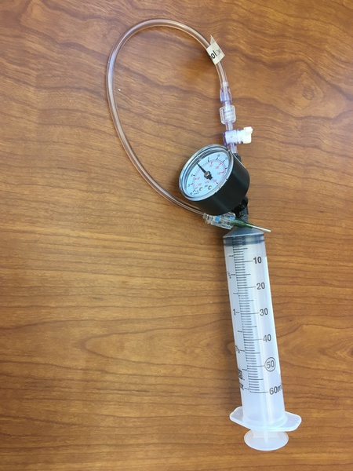
The behavior of two-phase systems will be compared to gas-only systems. This can be accomplished by using a syringe. In addition, you will heat water in a flask on a hot plate and collect data to explain the observed behavior. To determine the temperature-dependent vapor pressures for most substances you can use an online search. For water you can use an online steam table or a steam table app on your phone.
Lab
- Pressure in a syringe (water and ethanol)
- Mathematically how is absolute pressure related to gauge pressure? Note that the atmospheric pressure in Provo is typically 0.84 atm or 85 kPa.

- What are the vapor pressures of ethanol and water at 22 ̊C?

- Put about 5 mL of ethanol in a 30 mL syringe, if not already present. Do this by pouring a few mL into a cup or beaker first and drawing the liquid into the syringe. Remove any air from the syringe. To do this, point the exit port vertically upward and carefully push the plunger up, so that any air is expelled. Close the valve on the syringe tubing to block the opening for the next step.

- Push and pull on the plunger of the syringe in order to change the volume inside the syringe. What do you observe in terms of phases, pressure forces, and other physical behavior? How is it different when you push vs. pull the plunger? Physically explain your observations in terms of vapor pressure and atmospheric pressure.

- Add 15 mL of air into your syringe (along with the ethanol) and again plug the tip. Repeat your experiment above. What is different in this case and what is the same when you push vs. pull? Explain your observations.

- Repeat your experiment in parts d and e with water instead of ethanol. Do you notice any differences between the two liquids?

- Pipetting liquids (ethanol and water)
When pipetting liquids, sometimes it is observed that the liquid is “drippy” and keeps coming out of the pipette. Here you will explore this phenomenon.
a. Obtain 4 unused, dry disposable pipettes. Pour a few mL of ethanol in a small cup or beaker. Pour a few mL of water in another cup or beaker.

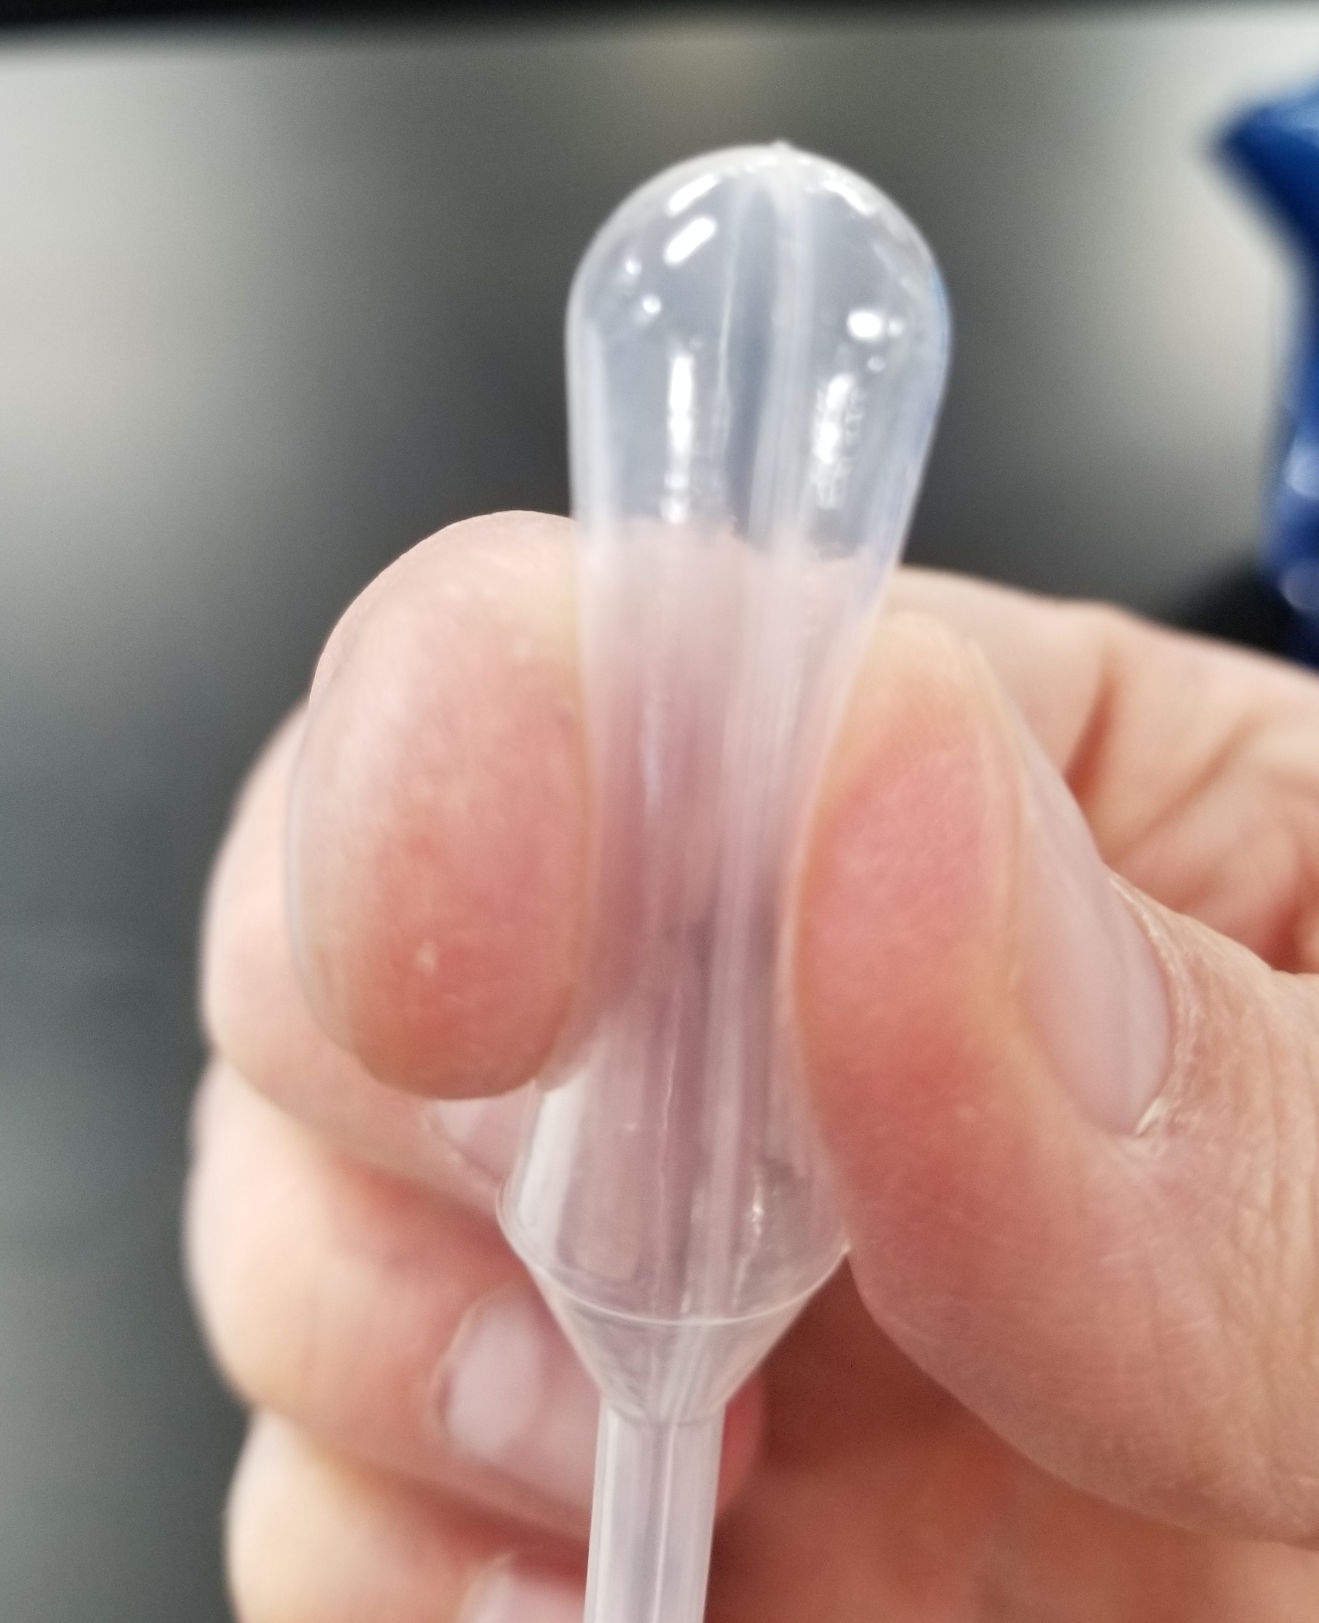
b. Gently squeeze the bulb of a pipette as shown in the picture. Insert the tip of the pipette in the liquid, keeping the bulb squeezed. Then release the pressure on the bulb so that it sucks the liquid into the stem of the pipette. Do not remove the tip of the pipette from the liquid until the bulb is fully expanded. If you mess up this procedure, start over with a new dry pipette.

c. Remove the pipette from the beaker, while holding the tip downward and suspended above the beaker to catch any liquid. Make observations for the next two minutes. Repeat this for both liquids, using a new pipette each time.

d. Explain your observations in terms of the physical principles explored in this lab.

e. Put used pipettes in the garbage can, but keep the syringes (empty) with the lab equipment.

- Mixtures with temperature change (water) – For this step you will need to use the flask with water that has a pressure gauge and thermocouple. Use some insulated gloves available in the lab when handling the flask. Under no circumstances should you heat the water temperature above 70 ºC or to a pressure greater than 2.5 psi.
  - Write down the initial temperature and pressure of the flask system. Carefully place the flask on the hot plate. Ensure that tube leading to the pressure gauge isn’t kinked and that the bottom of the flask is fully in contact with the heat plate. Plug in and turn on the heat plate to about 50% of full scale to begin heating the water in the flask. As the water heats, record several (4 or 5) measurements of temperature and pressure. Turn off the hot plate when the temperature reaches 65 ºC.

  - Using the insulated glove to protect your hand, remove the flask from the hot plate. Unplug the hot plate. As the flask cools, record several (5 or 6) temperatures and pressures. Explain why the pressure inside is greater when the liquid is cooling for a given temperature.

  - Submit a plot of points showing the temperature versus pressure for the heating and cooling measurements you made. Make sure the plot is properly labeled so that someone looking at it will be able to distinguish which measurements were made during heating (or cooling). Also plot the true vapor pressure for water as a line. Please also give several reasons why your data is different than the actual vapor pressure of water.

  - Sometimes in engineering, we leave out the dynamics of processes and focus on the equilibrium or steady state condition. How could understanding such a principle (reaching steady state can take some time) have prevented the serious accident detailed here: https://youtu.be/0DA--nMkWeA ?

_________________________________________________________________________________
Grading Rubric (to be completed by TAs)
 | Points | Max
Completed Activities and write-up |  | 6
Accurate calculations and reasonable estimates |  | 3
Safety and cleanup: TA initial:______ |  | 1
Total |  | 10

